**GENERAL SKILLS**

1. **PW Crack 5**

Can you crack the password to get the flag?Download the password checker [here](https://artifacts.picoctf.net/c/33/level5.py) and you'll need the encrypted [flag](https://artifacts.picoctf.net/c/33/level5.flag.txt.enc) and the [hash](https://artifacts.picoctf.net/c/33/level5.hash.bin) in the same directory too. Here's a [dictionary](https://artifacts.picoctf.net/c/33/dictionary.txt) with all possible passwords based on the password conventions we've seen so far.

For this one, I used the strip method given in the hint to trim the whitespaces and try out all combinations in dictionary. Code is given below.

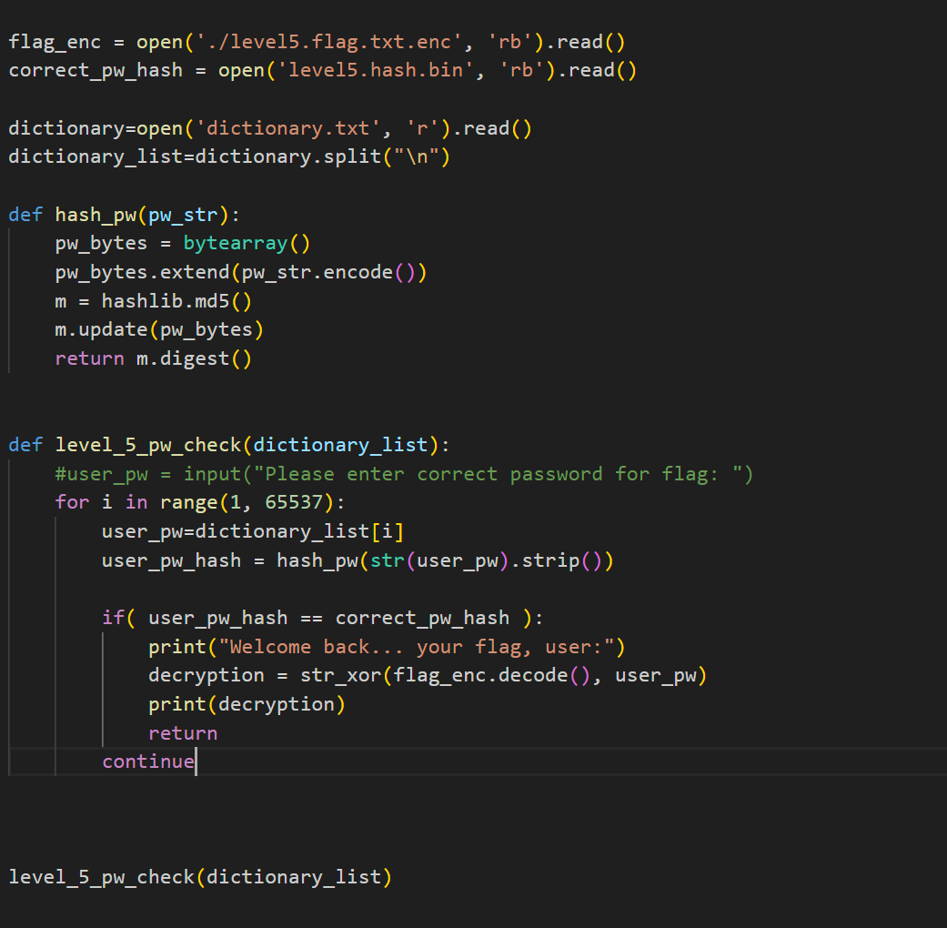



1. **Repetitions**

Can you make sense of this file?Download the file [here](https://artifacts.picoctf.net/c/474/enc_flag).

The file was base64 encoded multiple times so I decoded it multiple times to get the flag.

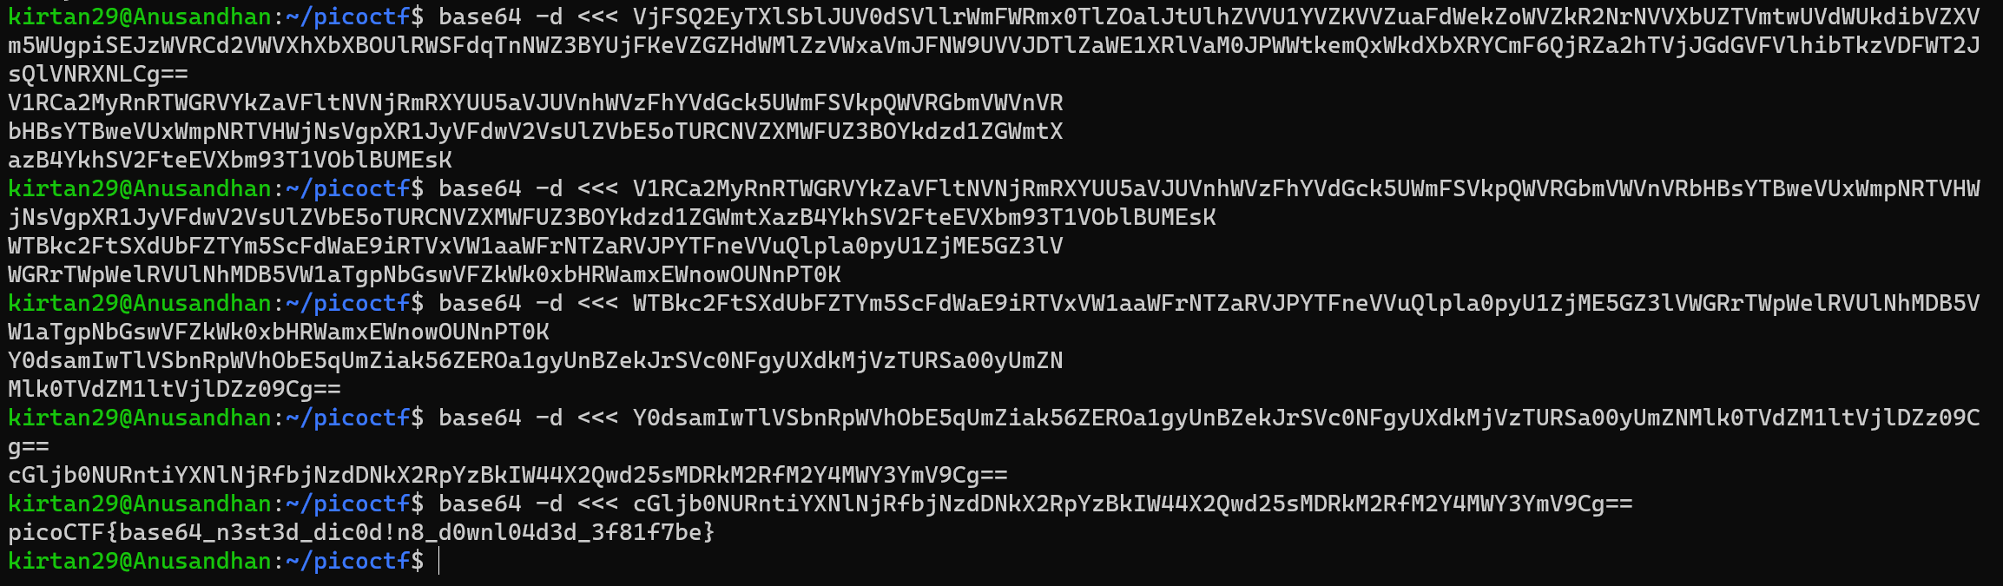

1. **Useless**

There's an interesting script in the user's home directory. Additional details will be available after launching your challenge instance.

I connected to the saturn.picoctf.net using ssh

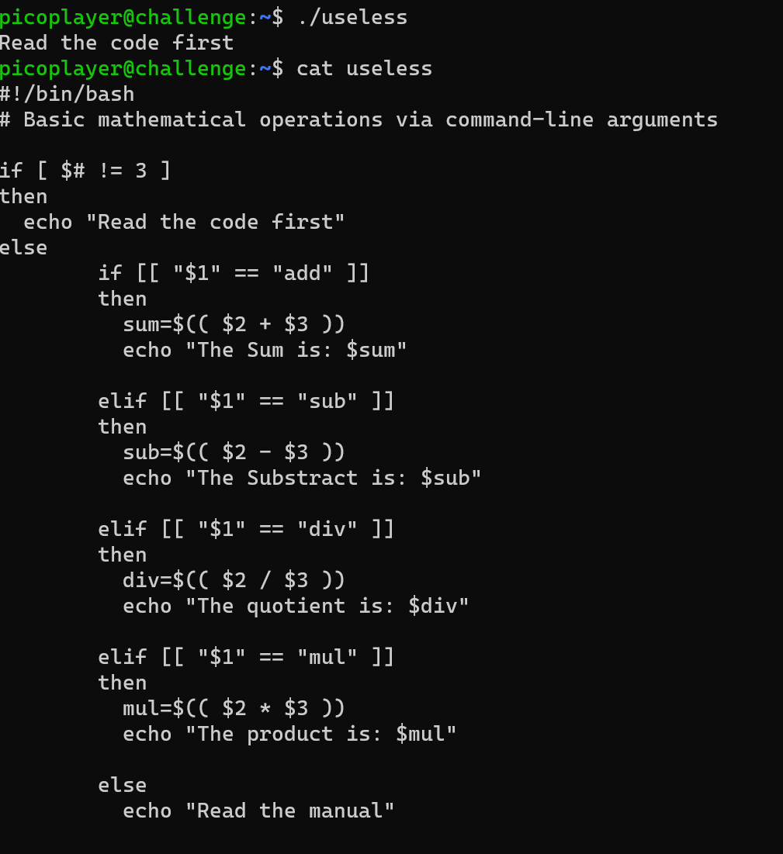

While reading the file, I noticed the else statement “Read the manual”. I opened the manual with the man command which had the flag.

